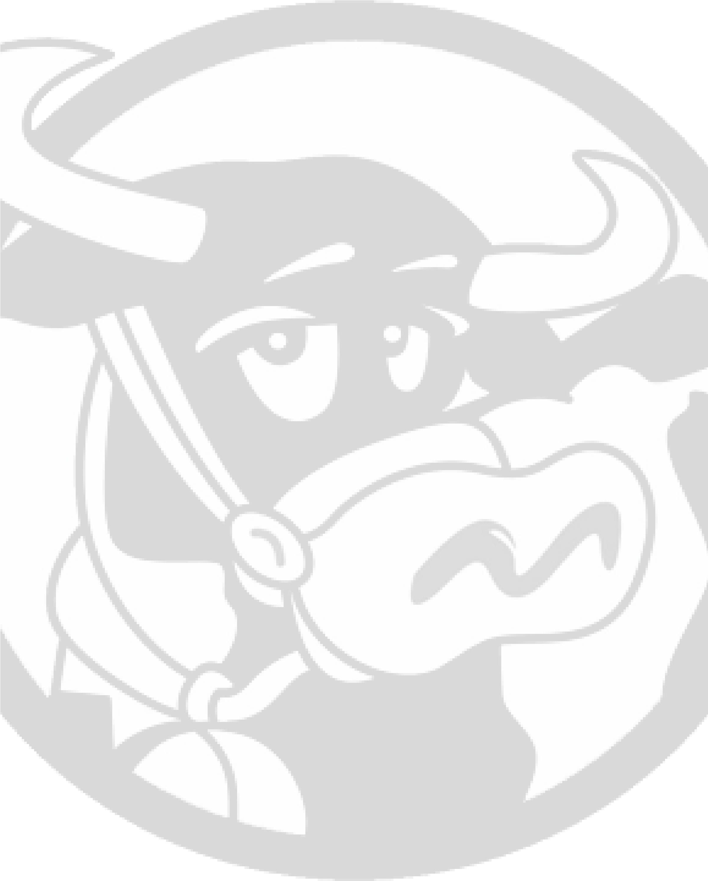
WINCHESTER DAIRYFEST
SponsorshipPackage
WWW.WINCHESTERDAIRYFEST.COM
2026
Sponsorship Coordinators:
Linda Barkley / Emily Ladouceur
sponsorship@winchesterdairyfest.com
📞
613-878-7047 (Linda)
📞
819-319-8771 (Emily)
Winchester Dairyfest was founded in 1988 by a dedicated group of local merchants to celebrate Winchester’s
Centennial year. What began as a special milestone celebration quickly became a cherished annual tradition.
Joel Steele, one of Dairyfest’s founding leaders, helped establish the strong foundation that ensured the festival
would continue to grow and thrive for generations. His vision helped root Dairyfest as a signature August event the
community looks forward to each year.
Today, the current committee proudly carries that tradition forward — celebrating Winchester’s country roots
while bringing together agriculture, the arts, local businesses, and families. Dairyfest continues to strengthen
community spirit, connection, and pride across North Dundas.
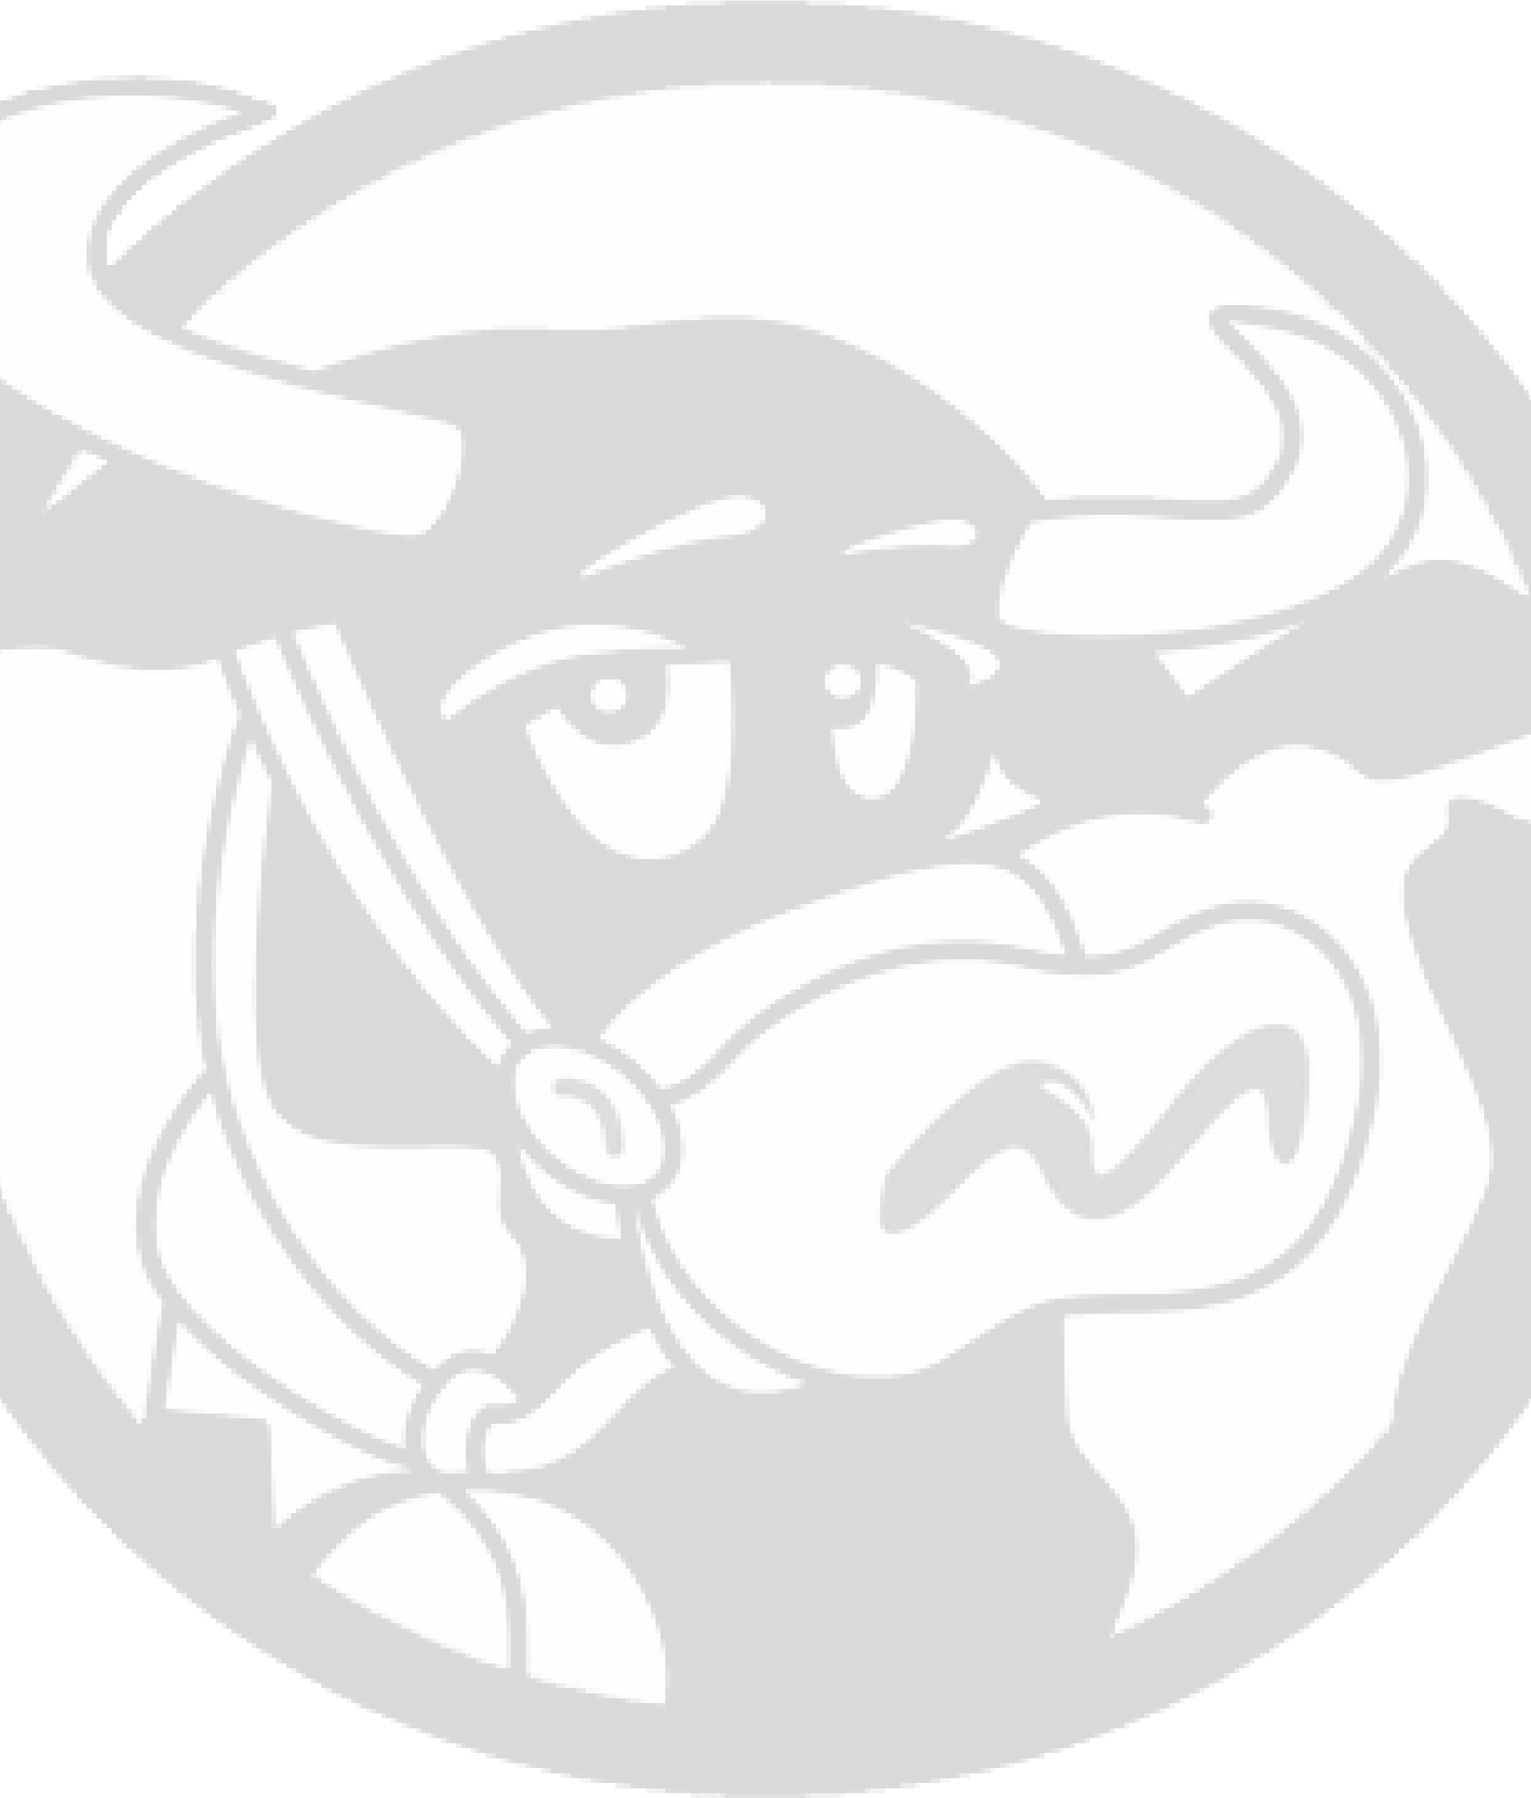
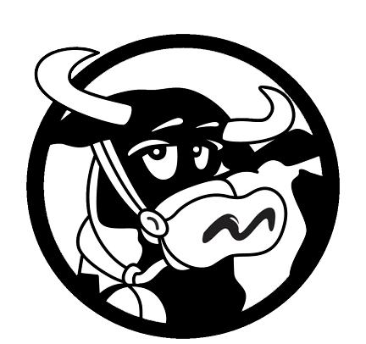
COMMUNITY DRIVEN
organizing and providing a free event for
the community of all ages
VOLUNTEER RUN
every
member
of
our
committee
is
a
volunteer from the community
TRADITION
help us keep Winchester Dairyfest in the
community of North Dundas
WHY
CHOOSE
US?
Come celebrate your country roots at Winchester’s local agricultural festival!
Join us for three exciting days

— filled with something for everyone.
We are excited to partner with Winchester Bike Night on Friday to kick off the festivities.
Saturday and Sunday will showcase:
Vendor Market
Live Music
Car Show
Tractor Display & Parade
Family Fun Zone
Petting Zoo
And more!
Dress your best cowboy or cowgirl and get ready to stomp your feet, play games, and dance
the afternoons away.
To make this event free and accessible for the community, we are seeking sponsorships and
partnerships with local businesses like yours.
✨
Bonus: Any sponsorship valued at $250 or more will receive a special visit from the
Winchester Dairyfest Cow in the weeks leading up to the event for photos and promotional
opportunities.
We are grateful for your support of Winchester and North Dundas local events.
Winchester Dairyfest
Aug 7th - 9th
SPONSORSHIP PACKAGES
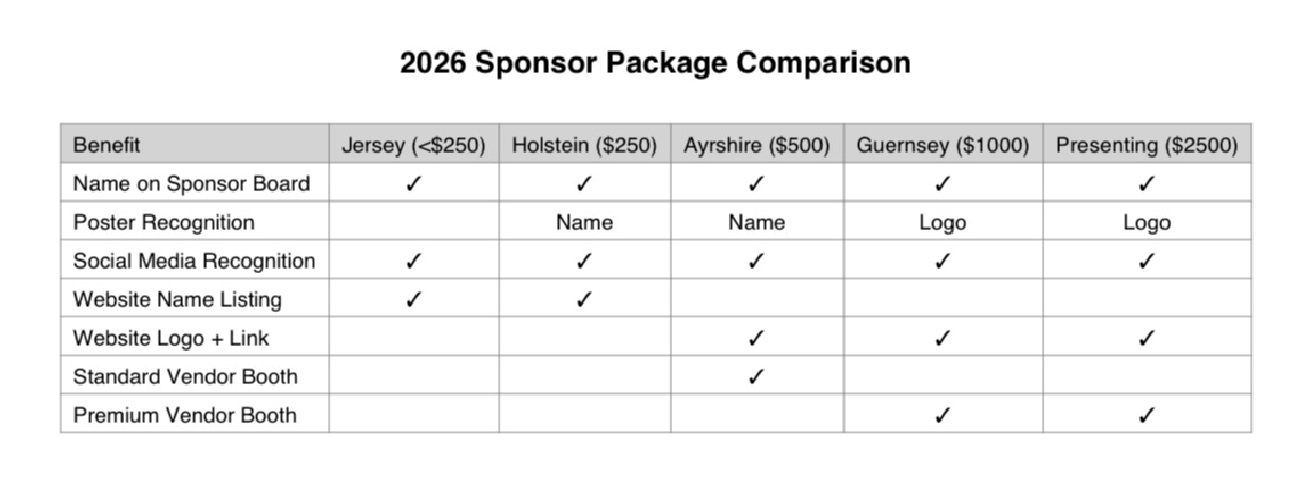

For additional questions please contact: Sponsorship Coordinators:
Linda Barkley
📞 613-878-7047
Emily Ladouceur 📞 819-319-8771 sponsorship@winchesterdairyfest.com

SPONSORSHIP DEADLINE
To be recognized in promotional materials, the sponsorship deadline is July 18, 2026. We will happily continue to accept contributions after this date. Thank you!

02
Company Information
Company Name: _______________________________________
Name you would like used in advertising:
________________________________________________________
Contact Person: _______________________________________
Mailing
Address: _______________________________________
Postal Code: _______________

Phone: _______________
Email: _______________________________________
Level of Sponsorship
□
Jersey ($____)
□
Holstein ($250)
□
Ayrshire ($500)
□
Guernsey ($1000)
□
Presenting ($2500)
Payment Information
Please make cheques payable to:
Township of North Dundas
Mail to:
Attn: Aaron Dellah – Winchester Dairyfest
P.O. Box 14
Winchester, Ontario
K0C 2K0
E-transfers can be made to:
treasurer@winchesterdairyfest.com
📞
(613) 441-2021
Donations can also be made online at:
www.winchesterdair
y
fest.co
m
/
s
ponsors

